Todo Sample Guid

First the application start is marked by this icon on the simuolator/phone

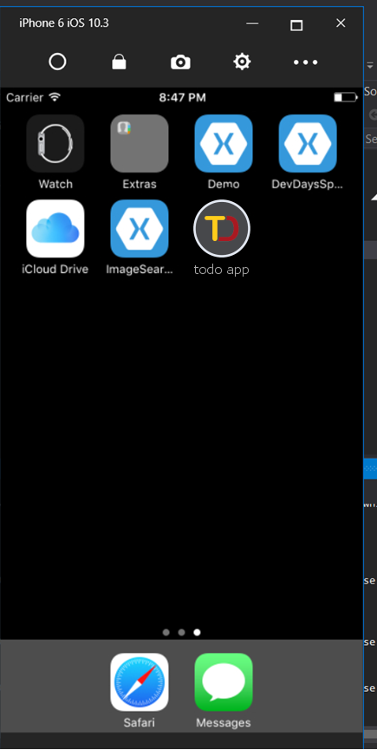

Once the application opens a splash should be appearing on startup

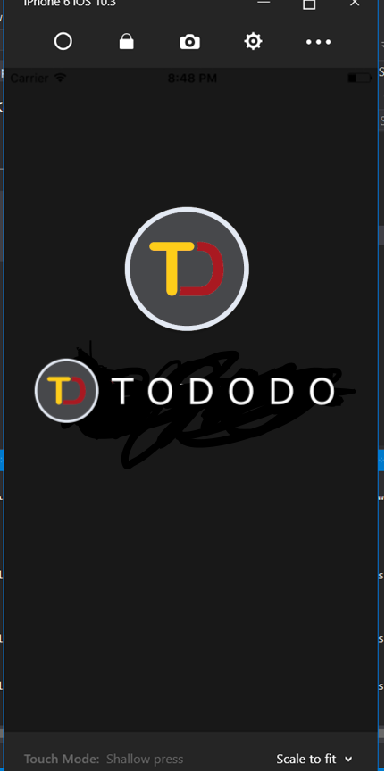

And then the login screen should appear as following please use the login credentials

UserName: name

Password: 123123

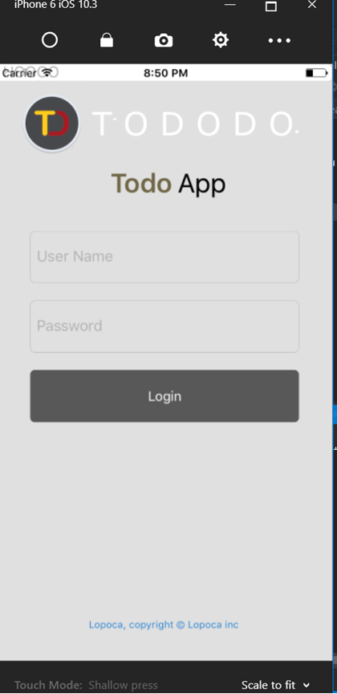

After login the loading indicator should appear and then the main screen will open

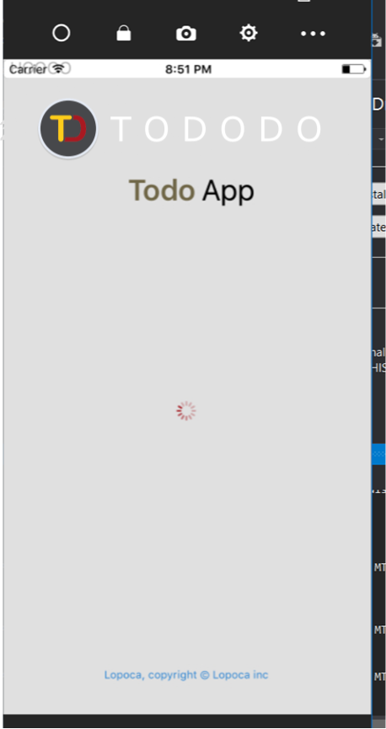

The main screen should be like this

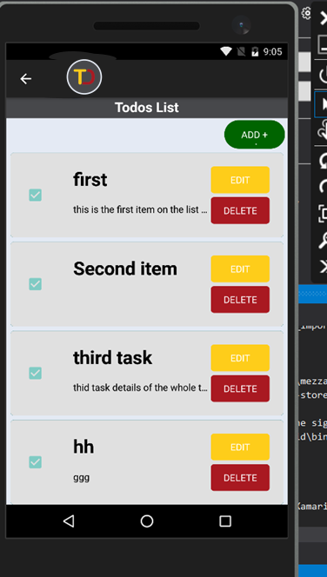

The syncing is manual so it needs to be triggered at the beginning of the app to initiate the syncing operation with the server

The sync button will be in the menu

As below



All functionalities like add edit and delete can be performed from this screen